Skeletal System


I’m Skeletor

Welcome to the world of
“bones”

Skeletal System

TITLE: The Skeletal System

DEVELOPED BY: Linda Mehlbrech

SUBJECT AND GRADE LEVEL: 6th grade science

STANDARDS:
SOUTH DAKOTA CONTENT STANDARDS
LIFE SCIENCE
GRADE 6

- #2 The students will describe the structure and function of the human skeleton.

SUMMARY:
- The students by the end of this unit will be able to identify the bones and joints
of the body and their function. They will also be able to recognize the proper
names of the bones as well as the common name.

OBJECTIVES:
- The students will identify the bones of the body
- The students will explain the purpose of the skeletal system.
- The students will name and give an example of the 5 joints.
- The students will recognize the common name and proper names of the bones.

ASSESSMENT:
- The students will be given daily 5 point quizzes as a review.
- A final paper and pencil test will be given
- The students will be graded on the research for their PowerPoint.
- The students will be graded on the development of their PowerPoint.
- The following rubric will be used to evaluate the bones and joints of the body.

RUBRIC:
 | 5 points | 4 points | 3 points | 2 points | 1 point
Skeleton | Identify all the 26 bones | Identify 24 or more bones | Identify 20 or more bones | Identify 17 or more bones | Identify 13 or more bones
Joints | Identify and give an example of all 5 joints | Identify 5 joints and 4 example or vice versa | Identify 4 joints and their examples | Identify 3 joints and their examples | Identify 2 joints and their examples

LEARNING ACTIVITIES:
- The students will be given a blank sheet of paper to draw the skeleton from
memory.

- The students will go to http://www.medtropolis.com/Vbody.asp to research one of the following diseases: osteoporosis, rheumatoid arthritis, gout, leukemia, or shin splints. The students will be put into groups to create and present their PowerPoint that will include the definition, cause, prognosis, risk factors, symptoms, diagnosis and treatment of that disease.
(Once internet site is found go to ‘health condition’ found on left hand side of page, scroll to disease and click)

- The students will be given a pretest using the skeletion O’Dem bones found at the internet site http://www.imcpl.lib.in.us/kids_bones.htm . Using the large TV screen for all to see, I will point to a bone and they will write the answer on paper. After the quiz, an introduction, they will be given a worksheet to fill in the the proper names of the bones.

- The students will go to the internet site as in Activity #2. At this site of Virtual Body, the students will go to “Bones Narrated” and “Zoom In” to find more information about the bones. This includes the names of the bones and the purpose of the skeletal system..

- The students will associate the common name of the bones with the proper scientific names of the bones.

- The students will learn the examples and types of joints in the body. The website www.stemnet.nf.ca/CITE/teacherhb.htm (skeleton) has good information on this.

WEBSITES:
http://www.stemnet.nf.ca/CITE/teacherhb.htm

http://www.imcpl.lib.in.us/kids_bones.htm

http://medtropolis.com/VBody.asp

Printouts from www.enchantedlearning.com

TECHNOLOGY USED:
- PowerPoint
- Internet
- Computer access

MATERIALS:
- Baxter (large screen tv with a computer)
- Computer available for each student

RESOURCES:

- http://www.enchantedlearning.com (Handouts) The Human Skeleton

- http://www.impcl.lib.in.us/kidsbones.htm (Handout) O ‘Dem Bones

- Barufald.,James ., George T. Ladd, Alice Johnson Moses, Herman and Nina Schneider, Heath Science, D.C. Heath and Company, 1984, Lexington,
pp. 80-92.

Human Skeleton
Label the Bones

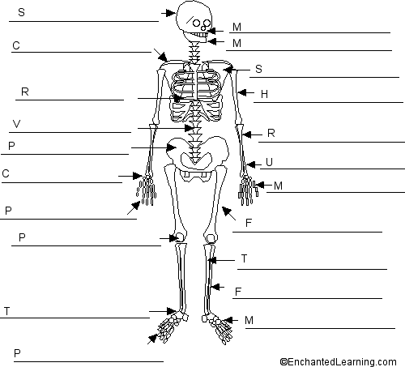

The major bones:
tibia  vertebrae  scapula  carpals  tarsals | phalanges  femur  ulna  humerus  fibula | maxilla  metatarsals  clavicle  metacarpals  pelvis  phalanges | ribs  skull  radius  patella  mandible

O'Dem Bones

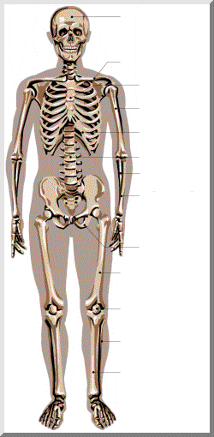
clavicle
humerus
column
pelvis
tibia
cranium
sternum
rib
ulna
radius
femur
patella



TYPES OF JOINTS

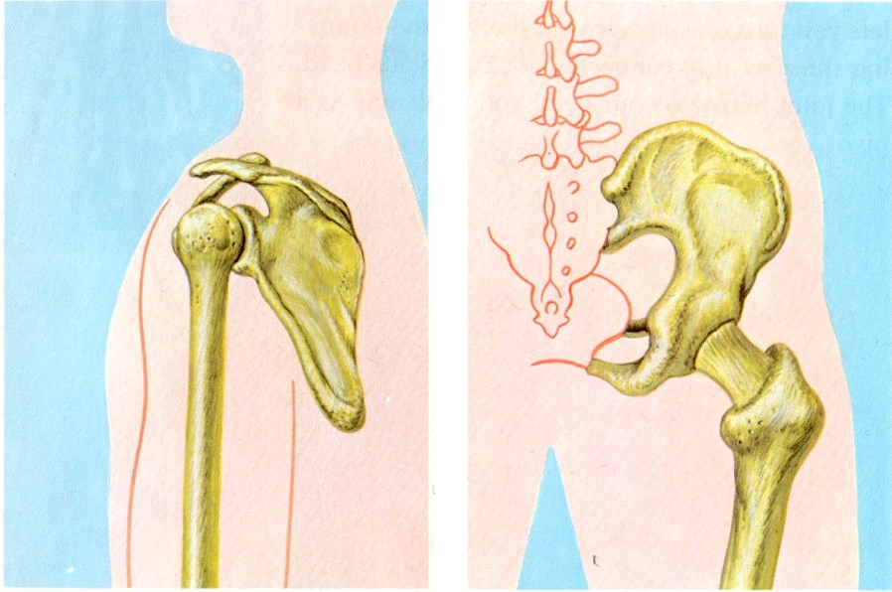 BALL AND SOCKET

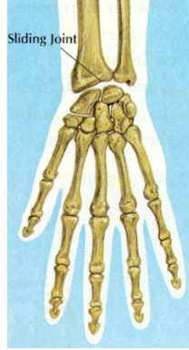 SLIDING JOINT

.
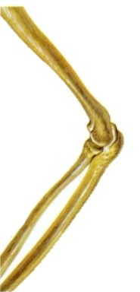 HINGE JOINT

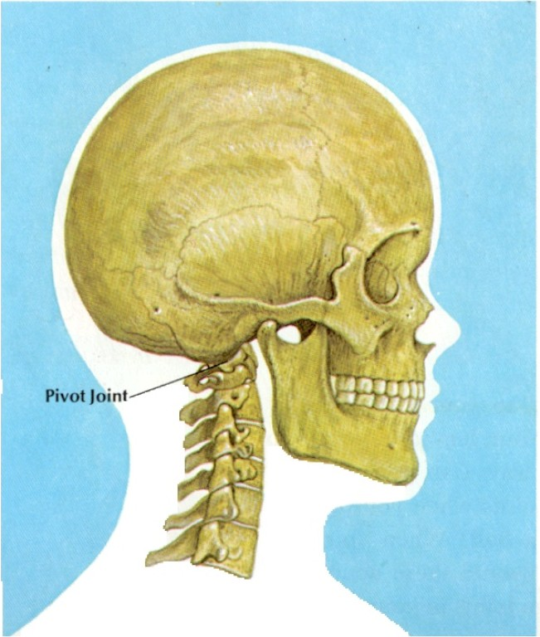 PIVOT JOINT
FIXED JOINT

Barufald.,James ., George T. Ladd, Alice Johnson Moses, Herman and Nina
Schneider, Heath Science, D.C. Heath and Company, 1984, Lexington,
pp. 80-92.

